**Project 1**

Title:

* Home Plant Grower’s DIY Site: Tips and tricks to home-grow various plants

Project Description:

* This application is created for users to look up various types of plants, and learn about their growing needs, complete with a picture of the plant they searched for (life cycle, amount of light/watering minimum/max precipitation, flowering, etc.).

User Story:

* User looks up a certain plant to learn about it:
  + Generate a picture of searched plant
  + Basic info about the plant (Formatted in a list/column/textarea/card (not sure yet)
  + Establish how it grows and if I can grow it at home/garden
  + BONUS: User will return a plant-friendly tune based on their search

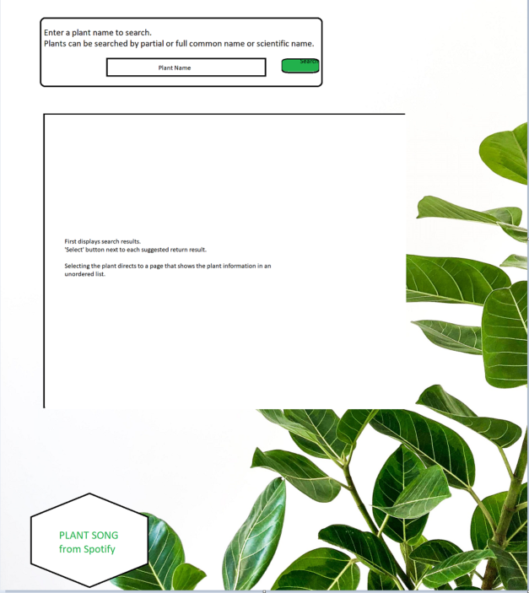Wireframe:

APIs

* + Trefle
  + GetGrowing
  + Plant.id
  + Spotify/Apple Music (BONUS GOAL)

Task Breakdown:

* Lindsay – Homepage of HTML/CSS Framework
* Lily – Search information (library, return results – HTML/CSS/JS), Music App usage
* Robby – Search information (library, return results – HTML/CSS/JS) Fetch usage, responses, and user interface
* Full team collaboration on JS functions